**Homework 4**

**Experiment:**

A variation of the LeNet was implemented. The models were trained for 40 epochs. Three different modifications were performed on the main proposed model. The experiment was also performed on Normalized (with training set mean and standard deviation) and Unnormalized images.

The three modifications made to the network are:

1. L2 norm was applied to the ADAM optimization with weight decay of 1e-3.
2. Batch Normalization was added after every ConvLayer and FC Layer.
3. Batch Normalization was added only after the first ConvLayer to experiment with the model performance.

**Results:**

**Normalized data**

**Main experiment:**

Since it is a small model, and the number of training data instances is low the performance was average. Below are some examples of images where the model could not predict right.

Failed normalized images examples:



The model did not generalize well. Since it is not very complex, it could not capture the correlation between the pixels well.

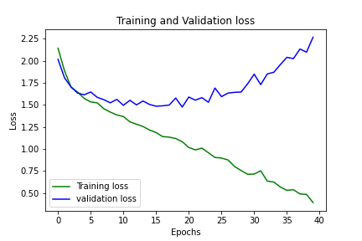

The training and validation loss are decreasing initially after a few epochs the validation loss increases this shows how the model is overfitting to the training set. The validation loss increases after decreasing steadily in between epochs 10-15.

Accuracy of the network on the test images: 47 % and the per class classification accuracy is as follows,

Accuracy for class airplane is: 62.0 %

Accuracy for class bird is: 40.6 %

Accuracy for class car is: 61.8 %

Accuracy for class cat is: 45.0 %

Accuracy for class deer is: 37.2 %

Accuracy for class dog is: 23.4 %

Accuracy for class horse is: 46.6 %

Accuracy for class monkey is: 37.8 %

Accuracy for class ship is: 70.0 %

Accuracy for class truck is: 45.6 %

The confusion matrix plotted as a heat map is show below for the main experiment, 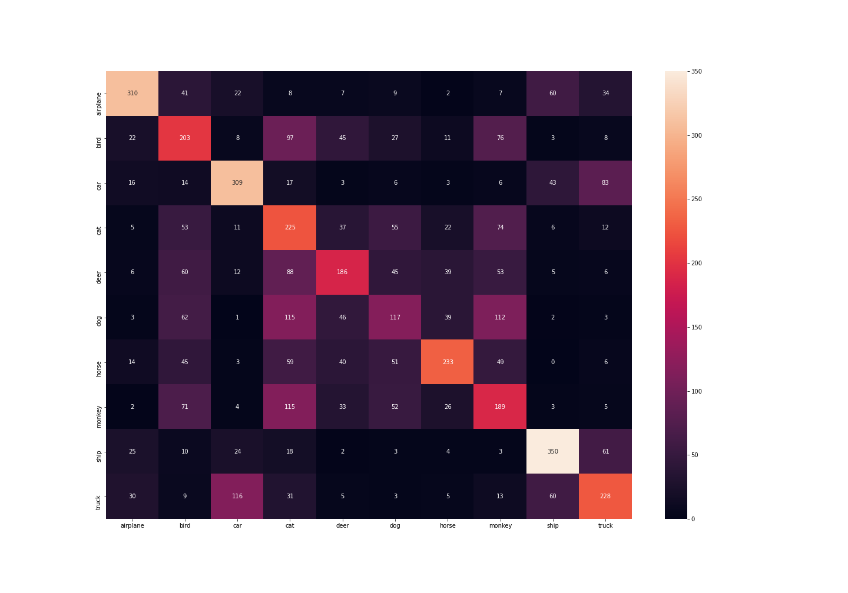

**L2 Norm**

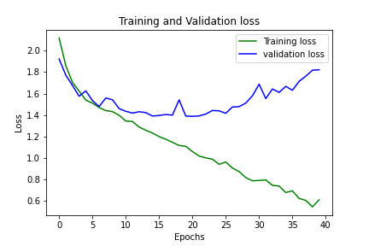

Similar results as the main experiment. Accuracy of the network on the test images: 46 % and the per class classification accuracy is as follows,

Accuracy for class airplane is: 58.4 %

Accuracy for class bird is: 28.4 %

Accuracy for class car is: 42.6 %

Accuracy for class cat is: 50.4 %

Accuracy for class deer is: 48.6 %

Accuracy for class dog is: 25.8 %

Accuracy for class horse is: 44.8 %

Accuracy for class monkey is: 38.0 %

Accuracy for class ship is: 73.4 %

Accuracy for class truck is: 58.2 %

The confusion matrix plotted as a heat map is show below for the experiment,

**Batch Norm**

Batch normalization was applied after every Conv Layer and FC Layer. The validation loss after each epoch is increasing. The model is overfitting on the train data.

Accuracy of the network on the test images: 13 % and the per class classification accuracy is as follows,

Accuracy for class airplane is: 13.0 %

Accuracy for class bird is: 13.2 %

Accuracy for class car is: 14.6 %

Accuracy for class cat is: 11.4 %

Accuracy for class deer is: 12.6 %

Accuracy for class dog is: 9.4 %

Accuracy for class horse is: 15.4 %

Accuracy for class monkey is: 13.0 %

Accuracy for class ship is: 16.8 %

Accuracy for class truck is: 13.0 %

The confusion matrix plotted as a heat map is show below for the experiment

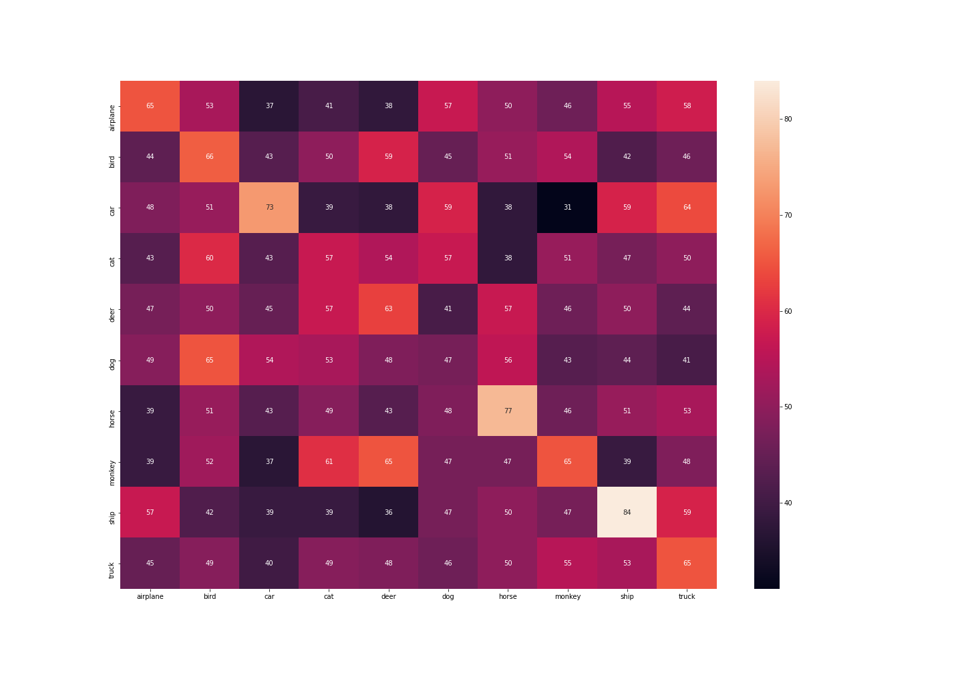

**Batch Norm on one layer**

Batch normalization was applied only after the first layer. The validation loss seems to be decreasing initially then the model is overfitting on the training data and so it increases.

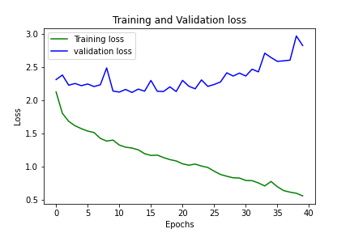

Accuracy of the network on the test images: 35 % and the per class classification accuracy is as follows,

Accuracy for class airplane is: 53.0 %

Accuracy for class bird is: 48.4 %

Accuracy for class car is: 38.2 %

Accuracy for class cat is: 25.0 %

Accuracy for class deer is: 25.4 %

Accuracy for class dog is: 14.6 %

Accuracy for class horse is: 33.4 %

Accuracy for class monkey is: 18.2 %

Accuracy for class ship is: 56.0 %

Accuracy for class truck is: 39.0 %

The confusion matrix plotted as a heat map is show below for the experiment.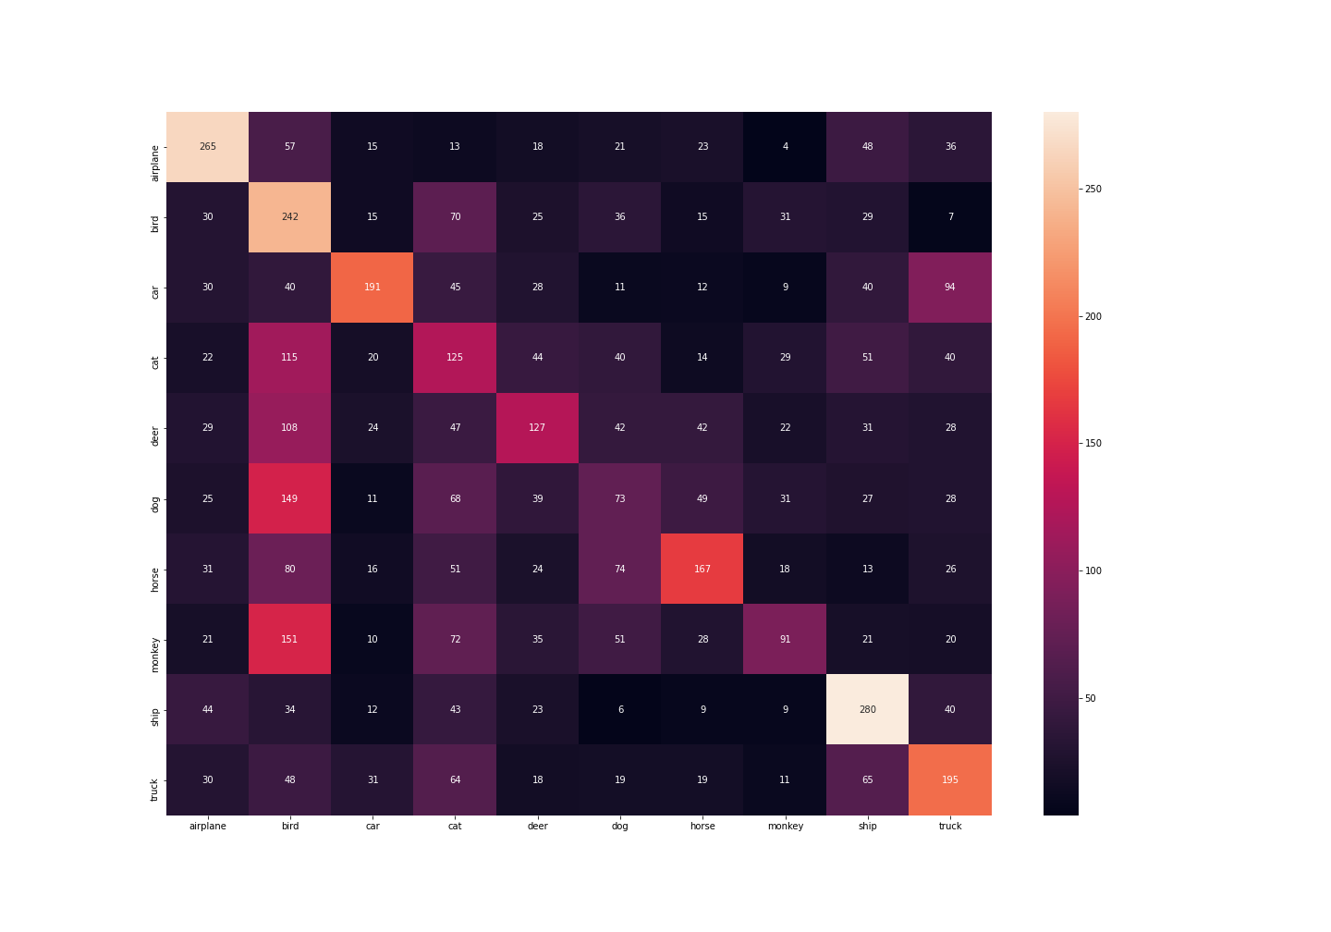

**Unnormalized data:**

Failed examples:



**Main experiment**

Both the training loss and the validation loss seem to be steadily decreasing. Accuracy of the network on the test images: 48 % and the per class classification accuracy is as follows,

Accuracy for class airplane is: 69.0 %

Accuracy for class bird is: 35.4 %

Accuracy for class car is: 77.2 %

Accuracy for class cat is: 23.6 %

Accuracy for class deer is: 46.2 %

Accuracy for class dog is: 16.2 %

Accuracy for class horse is: 61.0 %

Accuracy for class monkey is: 42.8 %

Accuracy for class ship is: 73.4 %

Accuracy for class truck is: 40.8 %

The confusion matrix plotted as a heat map is show below for the main experiment.

**L2 norm**

The validation loss is almost steadily decreasing with the training loss. Overall, the L2 norm model performed better than the other models.

Accuracy of the network on the test images: 46 % and the per class classification accuracy is as follows,

Accuracy for class airplane is: 71.4 %

Accuracy for class bird is: 30.0 %

Accuracy for class car is: 57.2 %

Accuracy for class cat is: 43.2 %

Accuracy for class deer is: 37.4 %

Accuracy for class dog is: 20.6 %

Accuracy for class horse is: 58.8 %

Accuracy for class monkey is: 31.6 %

Accuracy for class ship is: 47.6 %

Accuracy for class truck is: 70.0 %

The confusion matrix plotted as a heat map is show below for the experiment.

**Batch Normalization**

Batch normalization was applied after every Conv Layer and FC Layer. The validation loss after each epoch is increasing. The model is overfitting on the train data.

Accuracy of the network on the test images: 13 % and the per class classification accuracy is as follows,

Accuracy for class airplane is: 15.0 %

Accuracy for class bird is: 13.0 %

Accuracy for class car is: 12.4 %

Accuracy for class cat is: 12.8 %

Accuracy for class deer is: 14.0 %

Accuracy for class dog is: 13.4 %

Accuracy for class horse is: 13.0 %

Accuracy for class monkey is: 12.4 %

Accuracy for class ship is: 13.8 %

Accuracy for class truck is: 11.6 %

The confusion matrix plotted as a heat map is show below for the experiment.

**Batch norm in only the first layer**

Batch normalization was applied only after the first layer. The validation loss seems to be decreasing initially then the model is overfitting on the training data.

Accuracy of the network on the test images: 36 % and the per class classification accuracy is as follows,

Accuracy for class airplane is: 45.8 %

Accuracy for class bird is: 33.2 %

Accuracy for class car is: 41.4 %

Accuracy for class cat is: 44.6 %

Accuracy for class deer is: 32.0 %

Accuracy for class dog is: 12.0 %

Accuracy for class horse is: 52.6 %

Accuracy for class monkey is: 16.2 %

Accuracy for class ship is: 46.4 %

Accuracy for class truck is: 37.0 %

The confusion matrix plotted as a heat map is show below for the experiment.

**Conclusion:**

The model seems to converge faster when batch normalization is included but it overfits the model and gives very poor performance on the test data. L2 norm model performed slightly better than the main model. If the number of training examples is increased the model might show better performance. We could use

early stopping techniques to stop training before the model overfits.